

Activity3.1a Linear Measurement with Metric Units

Introduction
Modern civilization cannot exist without measurement systems. Measurements are everywhere, and you use them every day. Every time you buy gas, check the outside temperature, or step on a weight scale, measurements are used to represent a quantity. The abilities to conduct, record, and convert measurements are necessary to understand our technological world and to carry on the business of living. The fields of science, engineering, and mathematicsuse measurements extensively in the processes of discovery and design.

An interesting aspect of measurement is that a single quantity can be measured in different ways. I may describe the height of a horse in hands, feet, or meters. I can give the length of a property line in chains, miles, or meters. The units commonly used to measure a quantity can change with time and across borders. In the past it was not necessary to understand the system of measurement used by people outside of your local area, but today the world is a global marketplace.

The United States is the only developed country that does not use the International System of Units. In order to participate in the global market, we must be able to understand and communicate using various measurement systems. An object that is designed in the United States may end up being manufactured in another country. Due to the global nature of technology, engineered objects must often be communicated in SI (modern metric) units.

With respect to measurements within the science, engineering, and mathematical communities, accuracy and precision of measurements is extremely important. Often the correctness of a measurement is critical to the work of scientist, engineers, and mathematicians and must be carefully considered.

In this activity you will practice taking linear using SI measurements with a metric ruler and correctly recording the measurements to reflect the precision of the measurement.

Equipment
- Engineering notebook
- Pencil
- Ruler –metric
- PLTW Engineering Formula Sheet

Procedure
Record the length of the rectangles shown in the following figure using SI units and the correct number of significant figures. Include the units in your answers.

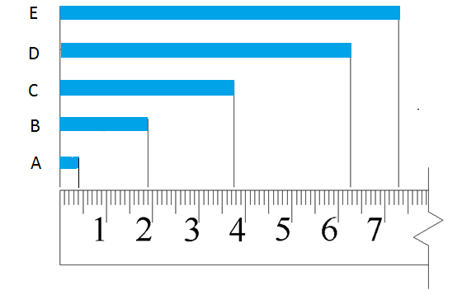

 | Distance | Measurement
1. | A | .4mm
2. | B | .19mm
3. | C | 30.7mm
4. | D | 60.2mm
5. | E | 70.3mm

Calculate each of the following lengths and record the answer using appropriate significant digits and the correct units. Show all calculations.

- What is the difference in the length of rectangles A and C?
26.7 mm
- What is the difference in the length of rectangles B and E?
51.4mm

- Using a metric ruler, measure the missing lengths in the figure below and enter the dimensions in the boxes. Be sure to use the correct number of significant digits and include units.
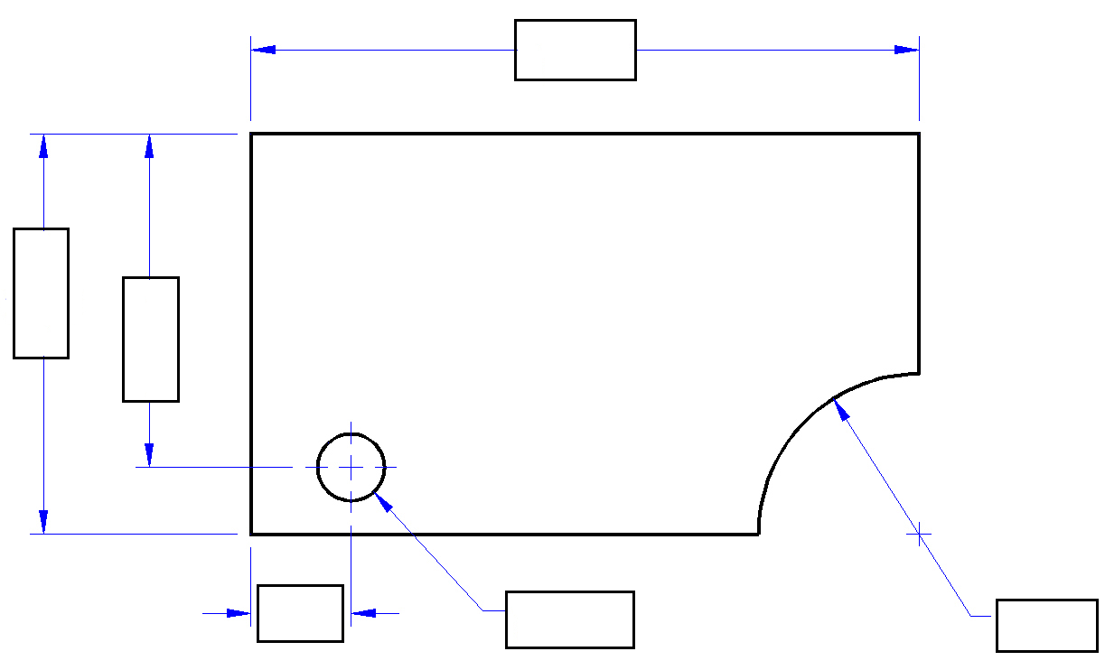
R
ø

.8mm
.8mm
.8mm
.7mm
.9mm
.7mm

- Measure and record the linear measurement of items in your classroom using appropriate metric units as directed by your instructor. Be sure to include the appropriate number of significant digits.
Object | Description of measurement | Measurement units | Measurement
CD | Diameter | cm | 4.8cm
Lined paper | Distance between lines | mm | 50mm

- In your engineering notebook, create a full scale isometric view of the object represented in the following sketch using the dimensions shown. Use a metric ruler to obtain the correct dimensions on your sketch.
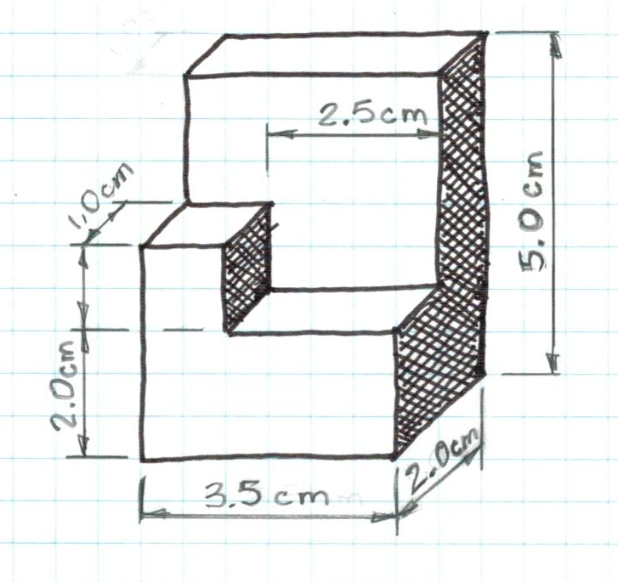

- What type of pictorial is shown in number 10? How can you tell?

Conclusion
- Explain the meaning of significant digits (or significant figures) in measurement.

- Why is the metric system used instead of the US customary system, and vice versa, in various parts of the world?

